Gerard J. Jacobs 3 on 3 Hockey Jamboree
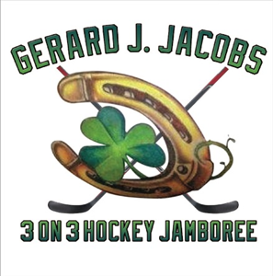

Dear Friends,

This year’s Gerard Jacobs 3 on 3 Hockey Jamboree will be at the Hallenborg Ice Pavillion at Billerica Memorial High School on Saturday, April 25, 2026. This annual event has been established as a gathering of friends and family, in fond memory of Gerard. All proceeds raised at the Jamboree, will be added to the scholarship or charitable trust funds that have been established in memory of Gerard.

Would you please consider becoming an Ice Sponsor, donating an item for our raffle or making a personal or corporate donation? Donations and sponsorships should be made payable to the “Billerica Scholarship Foundation” and reference the “Gerard J. Jacobs Scholarship”.

If you require a tax ID number for your donation, or perhaps you are able to extend this with a Corporate Matching Donation, please use this federal ID # 04-6001089.

On behalf of Gerard’s friends and family, we feel honored and appreciate that you choose to support the Annual Gerard J. Jacobs Hockey Jamboree.

Sincerely, Committee for the 3 on 3 Jamboree

Ice Sponsor Donation $100.00

Info: Name: ______________________________________
Address: ______________________________________ Phone: ______________________________________
Email: _______________________________________

Raffle Donation:_________________________________________________

$$ Donation $__________

Payment and questions can be submitted through our website, PLEASE VISIT, www.gerardjacobshockeyjamboree.com
Or mail to: c/o Sam Wilde, 10 Dean Road, York, ME 03909, cell 617-955-7334

